|  |  |  |
| --- | --- | --- |
| **THIS SWMS HAS BEEN PREPARED AND AUTHORISED BY D&M PLANT HIRE PTY LTD** | | |
| **ABN:** 57 010 542 506  **P:** (07) 3286 5088 | **A:** 55 Enterprise St Cleveland Qld 4163 | **P:** PO Box 1896, Cleveland QLD 4157  **E:** info@dandmplanthire.com.au |
| **Author:** Debra Wright | **Date:** 1st March 2019 | **Last Review Date:** 1st March 2019 |
| **Approved By:** Ray Phillips | **Signature:** | **Next Review Date:** 1st March 2020 |

|  |  |  |  |  |  |  |
| --- | --- | --- | --- | --- | --- | --- |
| **SWMS003 – OPERATION OF TIPPER TRUCKS & WATER TRUCKS** | | | | | | |
| **Description of Work / Activity Undertaken:** | Operation of Tipper Trucks & Water Trucks | | | | | |
| **Person responsible for implementation / monitoring:** | Operator | | | | | |
| **Includes the following “High Risk Activities”:** |  | Work involving excavation to a depth  greater than 1.5 metres |  | Work on or near pressurised gas  distribution mains & consumer piping |  | Work on or near chemical, fuel or  refrigerant lines |
|  | Work adjacent to a road or railways used  by road or rail traffic |  | Work on or near energised electrical  installations & services |  | Work on sites with movement of powered  mobile plant |

**This Safe Work Method Statement has been submitted to and approved by the following Principal Contractor / Customer**

|  |  |  |  |  |  |
| --- | --- | --- | --- | --- | --- |
| **Company Name:** |  | | | | |
| **Company Representative:** |  | | | | |
| **Site Address:** |  | | | | |
| **Period of Time** (max 12 months)**:** |  | | | | |
| **Approved By:** |  | **Signed:** |  | **Date:** |  |

**Please nominate the following PPE items required to be used when performing this task: The following Plant/Equipment is required to be used when performing this task:**

|  |  |  |  |  |  |  |  |  |  |  |  |
| --- | --- | --- | --- | --- | --- | --- | --- | --- | --- | --- | --- |
|  |  |  |  |  |  |  | **Other (list additional PPE items below):** |  |  |  | **Other (list additional plant/equipment items below):** |
| **◻**  **Safety Boots** | **◻**  **Safety Helmet** | **◻**  **Hearing Protection** | **◻**  **Eye Protection** | **◻**  **Respiratory Protection** | **◻**  **High Vis Clothing** | **◻**  **Hand Protection** | **Tippers** | **Water Trucks** | **Trailers** |

| **STEP** | **TASK / ACTIVITY** | **HAZARD/S** | **RISK SCORE**  **(BEFORE CONTROLS)** | | | **CONTROL AND SAFE WORK PROCEDURES** | **RISK SCORE**  **(AFTER CONTROLS)** | | | **RESPONSIBLE PERSON** |
| --- | --- | --- | --- | --- | --- | --- | --- | --- | --- | --- |
| **L** | **C** | **R** | **L** | **C** | **R** |
| 1. | Arrival on site | Site management unaware of works  Incorrect machine / operator scheduled  Non-compliance of truck | C | 3 | H 13 | 1. At time of booking / scheduling sufficient information gathered as to determine particular needs of the site and materials to be shifted. 2. Type of truck selected to suit these particular   needs addressing issues such as site terrain and conditions, rated capacity.   1. Operator’s and applicable load charts maintained in cabin at all times. 2. Operator to have relevant licences/ cards on site at all times. | E | 3 | M6 | Project Manager Operations Manager Driver |
| 2. | Pre-site discussion and planning with principal contractor | Unforeseen hazards Unaware of site policies | C | 3 | H 13 | 1. A pre-work discussion will be held and site specific induction attended with the principal contractor to determine:    * Location of existing services including electricity and underground services;    * General site terrain;    * Intended location for loading.    * Anticipated scheduling and impact of other trades on site at the time of the works;    * Other issues to plan and allow for the safe performance of works. | E | 3 | M6 | Project Management Driver |
| 3. | Access around site | Slips, trips and falls | C | 3 | H 13 | 1. General access ways to be clear of hazards. 2. Materials/equipment not to be stored in access ways. | E | 3 | M6 | Driver |
| 4. | Pre-work inspection / assessment | Existing services Plant Failure | C | 3 | H 13 | 1. Prior to commencing work a pre-work inspection to be performed. 2. Items assessed to include location of electrical hazards, site terrain, availability and condition of PPE and first aid equipment and adequacy of this SWMS. 3. Pre-operational inspection performed to ensure truck is free from defects or faults. Inspection to include the following:    * Correct tyre pressure;    * Park / foot brakes;    * Steering    * Warning devices – horn, flashing lights, reversing beeper, brake lights    * Brake and other fluid levels    * Seat belts, other safeguards as per manufacturer’s recommendations. | E | 3 | M6 | Driver |

|  |  |  |  |  |  |  |  |  |  |  |
| --- | --- | --- | --- | --- | --- | --- | --- | --- | --- | --- |
| **STEP** | **TASK / ACTIVITY** | **HAZARD/S** | **RISK SCORE**  **(BEFORE CONTROLS)** | | | **CONTROL AND SAFE WORK PROCEDURES** | **RISK SCORE**  **(AFTER CONTROLS)** | | | **RESPONSIBLE PERSON** |
| **L** | **C** | **R** | **L** | **C** | **R** |
| 5. | Access in / out of trucks | Slips / trips / falls | C | 3 | H 13 | 1. Provision of adequate non-slip ladders, footholds, steps and grab rails so as to safely access cabins. 2. Correct use of these safeguards by operators. | E | 3 | M6 | Driver |
| 6. | Driving / operating vehicle | Falling objects Collision Overturn | C | 4 | E 18 | 1. Trucks only operated by appropriately classed license holder, experienced and competent persons. 2. Pre-operational inspection perform to include the following: - fluid and leaks, tyre pressure, mirrors, brake, seat belt mounting and suspension, warning devices including reversing alarm and lights etc. 3. Safe travel speed maintained and defensive driving techniques used. 4. Traffic rules and regulations and Site Traffic Management Plan adhered to at all times. 5. Area in direction of travel to be clear of people and obstructions. Use of a spotter or Traffic Controller where required. 6. Safe distance maintained from edge of embankments and other vehicles. 7. Vehicles maintained in accordance with manufacturer. Evidence of maintenance to be available. 8. Safe vehicle mass not to be exceeded with loading of materials and equipment. 9. Loads to be flagged where necessary and maximum overhang dimensions not to be exceeded. 10. Upon shut down, park brake engaged, wheels chocked (if necessary) and keys removed from vehicle. 11. Adequacy of the ground considered –rises and falls, existing or recently backfilled trenches. 12. Do not carry others on trucks - only in designated passenger seats. | E | 3 | M6 | Driver |

|  |  |  |  |  |  |  |  |  |  |  |
| --- | --- | --- | --- | --- | --- | --- | --- | --- | --- | --- |
| **STEP** | **TASK / ACTIVITY** | **HAZARD/S** | **RISK SCORE**  **(BEFORE CONTROLS)** | | | **CONTROL AND SAFE WORK PROCEDURES** | **RISK SCORE**  **(AFTER CONTROLS)** | | | **RESPONSIBLE PERSON** |
| **L** | **C** | **R** | **L** | **C** | **R** |
| 7. | Working near existing services | Electrocution Explosion | D | 5 | E 19 | 1. Existing services will be identified with the principal contractor prior to commencement. 2. An exclusion zone of 3 metres around overhead powerlines (up to 132kV) maintained which allows for sway and sag unless:    * Documentation from the power supply authority confirms the lines have been de- energised; or    * A suitably qualified safety observer is available when the crane could enter the exclusion zone and power supply authority   has been, as well as a documented safe system of work developed. | E | 5 | H 15 | Driver |
| 8. | Inspection, Repairs and Maintenance | Plant Failure | D | 4 | H 14 | 1. Planned inspections and preventative maintenance programs for trucks in accordance with manufacturer’s recommendations. 2. As a minimum this inspection program to include:    * Daily / pre-operational inspections;    * Nominated manufacturer’s servicing. 3. Inspections and maintenance to take place on level ground, with ignition off and wheels chocked if necessary. 4. Service log books kept and available. | E | 4 | H 10 | Driver |

|  |  |  |  |  |  |  |  |  |  |  |
| --- | --- | --- | --- | --- | --- | --- | --- | --- | --- | --- |
| **STEP** | **TASK / ACTIVITY** | **HAZARD/S** | **RISK SCORE**  **(BEFORE CONTROLS)** | | | **CONTROL AND SAFE WORK PROCEDURES** | **RISK SCORE**  **(AFTER CONTROLS)** | | | **RESPONSIBLE PERSON** |
| **L** | **C** | **R** | **L** | **C** | **R** |
| 9. | Work adjacent to a road or way | Collision Impact  Vehicle and mobile plant traffic | C | 5 | E 22 | *D&M Plant Hire working under principal*  *contractor traffic management plan*   1. All workers to be trained / inducted into Traffic Control Plan. 2. Safety instructions and directions of Traffic Control personnel to be followed. 3. Site rules and Site Traffic Management Plan to be adhered to at all times. 4. Traffic management devices including barriers, signage and bollards not to be interfered with, relocated or subjected to damage. 5. Defective / ineffective traffic control devices brought to the attention of the principal contractor 6. Workers familiar with the basic application of the Manual for Uniform Traffic Devices Part 3   and adherence to this Part. | E | 4 | H 10 | Principal Contractor Operator |
|  | Work adjacent to a road or way | Collision Impact  Vehicle and mobile plant traffic | C | 5 | E 22 | *Traffic Management Plan devised by D&M*  *Plant Hire Pty Ltd*   1. A traffic management plan to be developed by D&M Plant Hire Pty Ltd and all workers trained and familiar with the plan. 2. Traffic Management Plan to be approved by Principal Contractor prior to work commencing. 3. Road work signage and devices to be erected prior to work commencing and in accordance with AS 1742.3 4. Traffic control only by approved / accredited personnel. 5. Work zones to be delineated in accordance with Traffic Management Plan All workers to remain within the work zone, unless otherwise directed by Traffic Controllers 6. Continuous monitoring by supervisor of signage, devices and effectiveness of the TM and appropriate remedial action taken as necessary. | E | 4 | H 10 | Supervisor Operator |

|  |  |  |  |  |  |  |  |  |  |  |  |  |  |  |  |  |  |  |
| --- | --- | --- | --- | --- | --- | --- | --- | --- | --- | --- | --- | --- | --- | --- | --- | --- | --- | --- |
| **STEP** | | **TASK / ACTIVITY** | | **HAZARD/S** | | **RISK SCORE**  **(BEFORE CONTROLS)** | | | | **CONTROL AND SAFE WORK PROCEDURES** | **RISK SCORE**  **(AFTER CONTROLS)** | | | | | | **RESPONSIBLE PERSON** | |
| **L** | | **C** | **R** | **L** | | **C** | | **R** | |
| 10. | | Working in a dusty work zone | | Irritation, asthma and/or damage to operators lungs. | | C | 2 | M8 | 1. Where high levels of dust are generated and not suppressed by site controls, report incident to site management. Site management to implement controls in so far as it is practicable. 2. Ensure cabin windows are closed as practicable and air-conditioning is set to recycled and not vented. 3. Wear a dust mask as practicable. | | E | | 2 | | L3 | | Operator | |
| 11. | | Working in quarries or on sites where materials high in quartz are being cut or ground. | | Inhalation of silica dust leading to lung disease.  **Note**: *Silica particles are naturally occurring in quartz, and may be used in small percentages in the manufacture of cement and construction materials. The risk arises where silica particles become airborne during cutting, grinding or crushing.* | | D | 3 | M9 | 1. Where high levels of silica dust are generated and not suppressed by site controls, report incident to site management. Site management to implement controls in so far as it is practicable. 2. Ensure cabin windows are closed as practicable and air-conditioning is set to recycled and not vented. 3. Wear a respirator mask with P2 cartridges, as practicable. | | D | | 1 | | L2 | | Operator | |
| 12. | | Leave Site | | Damage to property or plant Struck by moving objects | | C | | 3 | H13 | 1. Areas left in a clean and tidy state. 2. Sign out procedures of principal contractor followed. 3. Environmental wash station / gravel driveways utilised. 4. Lock and secure site if required. 5. Traffic management procedures of principal contractor followed. | E | | 3 | | M6 | | Project Manager Operator | |

**Additional Hazards / Tasks / Special Precautions / Control Measure** *(to be completed where review / site specific conditions may determine necessary)*

Use the Risk Management Process on Page 8 of this document to determine appropriate control measures

|  |  |  |  |  |  |  |  |  |  |  |
| --- | --- | --- | --- | --- | --- | --- | --- | --- | --- | --- |
| **STEP** | **TASK / ACTIVITY** | **HAZARD/S** | **RISK SCORE**  **(BEFORE CONTROLS)** | | | **CONTROL AND SAFE WORK PROCEDURES** | **RISK SCORE**  **(AFTER CONTROLS)** | | | **RESPONSIBLE PERSON** |
| **L** | **C** | **R** | **L** | **C** | **R** |
|  |  |  |  |  |  |  |  |  |  |  |
|  |  |  |  |  |  |  |  |  |  |  |
|  |  |  |  |  |  |  |  |  |  |  |
|  |  |  |  |  |  |  |  |  |  |  |

# Risk Management Process

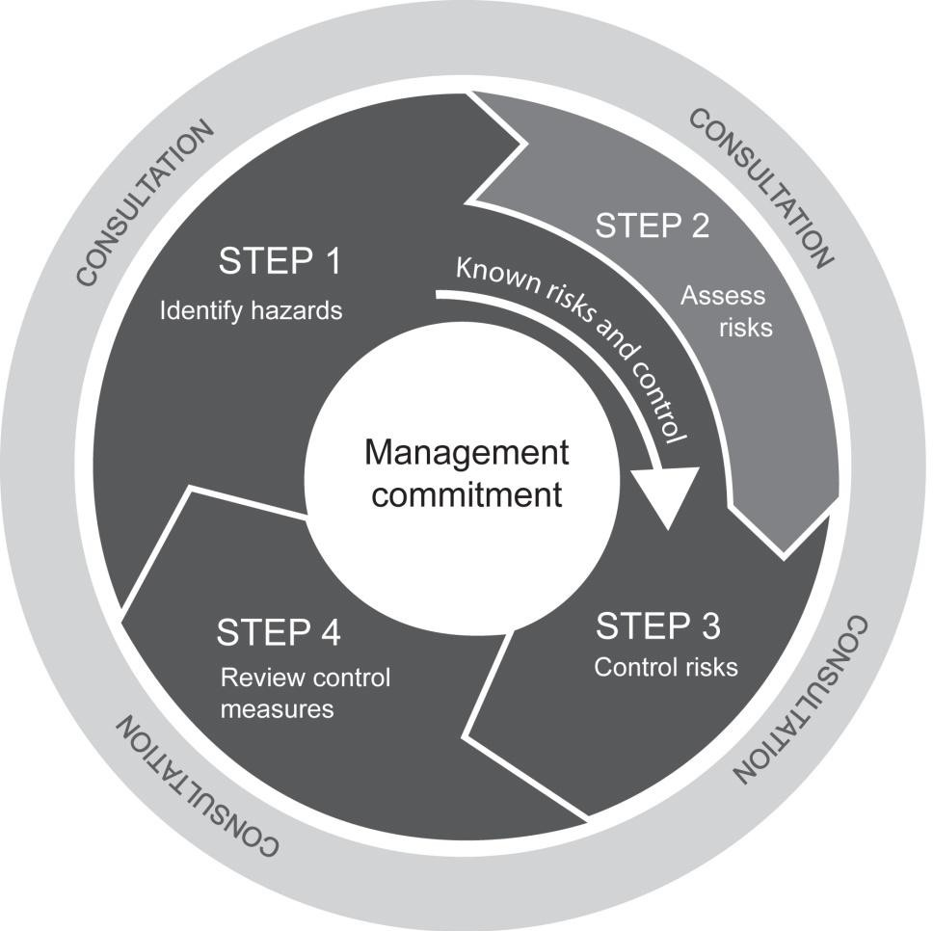

**Step 1 - Assessment of Risk**

1. The likelihood of an incident occurring as a result of the hazard will first be assessed.
2. The consequences (if an incident did occur) will then be determined. To determine the possible consequences, a judgement on the severity of the potential outcome will be made.

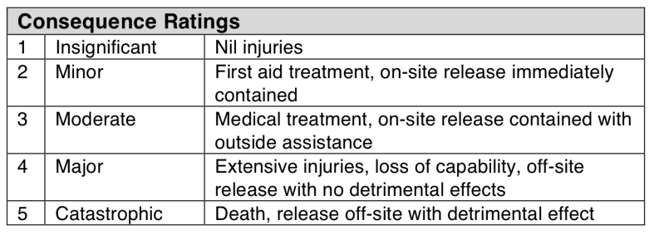

1. The likelihood and consequences estimates will then be combined to obtain a total risk score by using the following risk priority table.

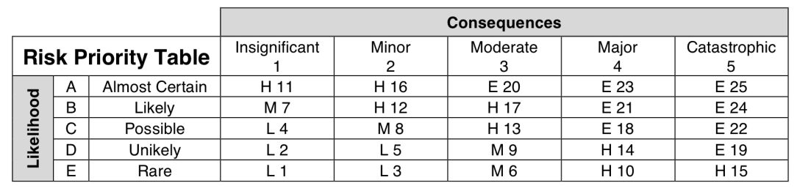

1. The following legend will be used to determine the response.

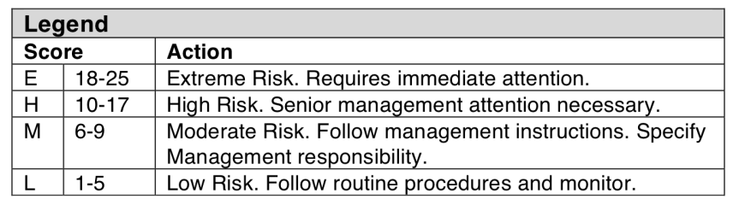

1. 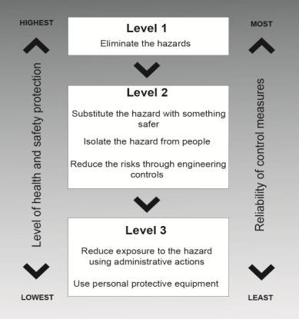Control measures will be implemented using the following hierarchy of controls.

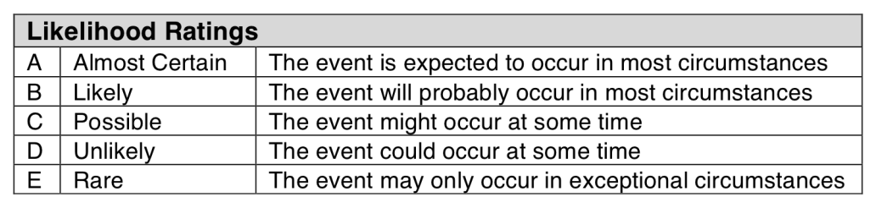

## Applicable Legislation, Standards, Competencies

|  |  |  |  |  |  |  |
| --- | --- | --- | --- | --- | --- | --- |
| **Relevant Legislation, Applicable Codes of Practices and Standards** | | | | | | |
| This Safe Work Method Statement has been developed to comply with the relevant legislation:  Work Health and Safety Act 2011 Work Health and Safety Regulation Environmental Protection Act 1994  Environmental Protection Regulation 2008  Environmental Protection (Waste) Policy and Regulation 2000 Environmental Protection (Water) Policy 2009  Environmental Protection (Noise) Policy 2008 Environmental Protection (Air) Policy 2008 | Relevant Codes of Practice, Standards and Guidelines as subordinate statute legislation including:  Hazardous Manual Tasks Code of Practice 2011  How to Manage Work Health and Safety Risks Code of Practice 2011 Managing the Work Environment and Facilities Code of Practice 2011 Work, Health and Safety Consultation Code of Practice 2011  Co-operation and Co-ordination Code of Practice 2011 Construction Work Code of Practice 2012  Excavation Work Code of Practice 2012  Managing Risks of Hazardous Chemicals in the Workplace Code of Practice 2012 Managing Noise and Hearing Loss at Work Code of Practice 2011  Plant Code of Practice 2005 | | | | | |
| **Training / Competencies / Certificates to perform work** | | | | | | |
| The following training / competencies are required to perform this task:  General Safety Induction Training (Construction Industry) Site Specific Induction (if required)  Work Activity Induction Training Equipment owner manuals  Safe Work Method Statements and Safe Work Procedures Training | Authorities to Work / Certificates of Competency for prescribed occupations / high risk work: (High Risk Work Certificate) | | | | | |
| ◻ | LE Excavator | ◻ | LS Skid Steer | ◻ | LB Front End Loader |
| ◻ | LS Skid Steer | ◻ | LZ Dozer | ◻ | DG Dogger |
| ◻ | LG Grader | ◻ | LP Scraper | ◻ | LR Roller |
| **Monitoring / Evaluation** | **Consultation & Communication** | | | | | |
| Measurement and evaluation will be an ongoing process performed principally by:   * Continuous monitoring by supervisor; * On site monitoring by Directors, General Manager, Operations Manager and Supervisor; * Formal site safety inspections against pre-determined criteria as per D&M Plant Hire Pty Ltd QHSEMS; * Formal incident investigation; and * Consultation with employees and contractors. | D&M Plant Hire Pty Ltd actively consult with workers and contractors through the following forms:   * Site visits / inspections by supervisors and partners; * Toolbox talks used to induct employees and contractors; * Regular staff meetings; * Correspondence to contractor via SMS, letter or email; * Company Newsletter; and * Other forums as determined. | | | | | |

**Consultation, Training and Competency Register**

|  |  |  |  |  |  |
| --- | --- | --- | --- | --- | --- |
| **Declaration by Employees and Contractors**  We, the undersigned, acknowledge that:   * This Safe Work Method Statement has been developed in consultation with us; and * We have been trained in the contents of this Safe Work Method Statement and are fully conversant with the safety procedures and precautions; and * We will work in accordance with the procedures listed in the Safe Work Method Statement. | | | | | |
| **Name** | **Signature** | **Date** | **Name** | **Signature** | **Date** |
|  |  |  |  |  |  |
|  |  |  |  |  |  |
|  |  |  |  |  |  |
|  |  |  |  |  |  |
|  |  |  |  |  |  |
|  |  |  |  |  |  |
|  |  |  |  |  |  |
|  |  |  |  |  |  |

|  |  |  |  |  |  |  |  |  |
| --- | --- | --- | --- | --- | --- | --- | --- | --- |
| **Doc / Record**  **No** | **Version** | **Date** | **Author** | **Approval** | **Sections Modified** | **Details of Amendments** | **Effective Date** | **Next Review** |
|  | 01 | 1/7/13 | Doug Phillips | Director | All | New document | 1/3/13 | 1/7/14 |
|  | 02 | 1/7/14 | Doug Phillips | Director | All | Reviewed | 1/7/14 | 1/7/15 |
|  | 03 | 1/7/15 | Doug Phillips | Director | All | Reviewed | 1/7/15 | 1/7/16 |
|  | 04 | 1/7/16 | Doug Phillips | Director | All | Reviewed | 1/7/16 | 1/7/17 |
|  | 05 | 1/7/17 | Ray Phillips | Director | All | New document | 1/7/17 | 1/7/18 |
| R30 | 01 | 1/7/18 | Ray Phillips | Director | All | Reviewed | 1/7/18 | 1/7/19 |
| R30.003 | 1.1 | 1/3/19 | Ray Phillips | Director | All | New document | 1/3/19 | 1/7/20 |
|  | 1.2 | 22/07/19 | Debra Wright | Manager | Selected | Updated |  |  |