|  |  |  |
| --- | --- | --- |
| **THIS SWMS HAS BEEN PREPARED AND AUTHORISED BY D&M PLANT HIRE PTY LTD** | | |
| **ABN: 57 010 542 506**  **P:** (07) 3286 5088 | **A:** 55 Enterprise St Cleveland Q 4163  **F:** (07) 3286 5088 | **P:** PO Box 1896, Cleveland QLD 4157  **E:** info@dandmplanthire.com.au |
| **Author:** Debra Wright | **Date:** 1st March 2019 | **Last Review Date:** 1/3/19 |
| **Approved By:** Ray Phillips | **Signature:** | **Next Review Date:** 1/3/20 |

|  |  |  |  |  |  |  |
| --- | --- | --- | --- | --- | --- | --- |
| **SWMS004 – GENERAL SITE ACTIVITIES** | | | | | | |
| **Description of Work / Activity Undertaken:** | General Site Activities | | | | | |
| **Person responsible for implementation / monitoring:** | Operator | | | | | |
| **Includes the following “High Risk Activities”:** |  | Work involving excavation to a depth  greater than 1.5 metres |  | Work on or near pressurised gas  distribution mains & consumer piping |  | Work on or near chemical, fuel or  refrigerant lines |
|  | Work adjacent to a road or railways used by road or rail traffic |  | Work on or near energised electrical installations & services |  | Work on sites with movement of powered mobile plant |

**This Safe Work Method Statement has been submitted to and approved by the following Principal Contractor / Customer**

|  |  |  |  |  |  |
| --- | --- | --- | --- | --- | --- |
| **Company Name:** |  | | | | |
| **Company Representative:** |  | | | | |
| **Site Address:** |  | | | | |
| **Period of Time** (max 12 months)**:** |  | | | | |
| **Approved By:** |  | **Signed:** |  | **Date:** |  |

**The following PPE items required to be used when performing this task: The following Plant/Equipment is required to be used when performing this task:**

|  |  |  |  |  |  |  |  |  |
| --- | --- | --- | --- | --- | --- | --- | --- | --- |
|  |  |  |  |  |  |  | **Other (list additional PPE items below):** | **As determined by Principal Contractor / Customer (list items below):** |
| **☑**  **Safety**  **Boots** | **☑**  **Safety**  **Helmet** | **☑**  **Hearing**  **Protection** | **☑**  **Eye**  **Protection** | **☑**  **Respiratory**  **Protection** | **☑**  **High Vis**  **Clothing** | **☑**  **Hand**  **Protection** |

|  |  |  |  |  |  |  |  |  |  |
| --- | --- | --- | --- | --- | --- | --- | --- | --- | --- |
| **TASK / ACTIVITY** | **HAZARD/S** | **RISK SCORE**  **(BEFORE CONTROLS)** | | | **CONTROL AND SAFE WORK PROCEDURES** | **RISK SCORE**  **(AFTER CONTROLS)** | | | **RESPONSIBLE PERSON** |
| **L** | **C** | **R** | **L** | **C** | **R** |
| Pre-start discussion and planning with client / principal contractor | Unidentified hazards Unaware of site policies | C | 3 | H 13 | 1. A pre-work discussion will be held and Client specific induction attended with the principal contractor / client to determine:    * Location of existing services including electricity and underground services;    * Areas allocated for storage of materials and equipment;    * Anticipated scheduling and impact of other trades at the time of the works;    * Other issues to plan and allow for the safe performance of works. | E | 3 | M6 | Project Management Supervisor  All workers |
| Adequacy of Plant | Plant Failure | C | 3 | H 13 | 1. Type of machines and plant selected suit particular needs addressing issues such as terrain and conditions, existing services, rated capacity and characteristics. 2. Operator’s manuals kept / applicable load charts available at all times. 3. Manufacturer’s data plates and registration details in clear view. | E | 3 | M6 | Operators |
| Assessment of work areas | Unidentified hazards | C | 3 | H 13 | 1. Inspection of general work areas and equipment to ensure:    * Working platforms are adequate and contain edge protection where required;    * Lighting (natural or other) is adequate;    * Weather conditions are suitable for the task to be performed;    * Tools and equipment are free of defects / in good working order.    * Personal protective equipment required is in good working order.    * First aid kit is readily available. | E | 3 | M6 | All workers |

|  |  |  |  |  |  |  |  |  |  |
| --- | --- | --- | --- | --- | --- | --- | --- | --- | --- |
| **TASK / ACTIVITY** | **HAZARD/S** | **RISK SCORE**  **(BEFORE CONTROLS)** | | | **CONTROL AND SAFE WORK PROCEDURES** | **RISK SCORE**  **(AFTER CONTROLS)** | | | **ESPONSIBLE PERSON** |
| **L** | **C** | **R** | **L** | **C** | **R** |
| Storage of materials and housekeeping | Slips, trips falls | C | 3 | H 13 | 1. Equipment and plant to be delivered and stored where arranged with client / principal contractor. 2. Work areas to be maintained in a clear and tidy condition. 3. At end of each day a thorough clean up and inspection to be performed to ensure all hazards have been removed or controlled. | E | 3 | M6 | All workers |
| Handling of  materials and equipment | Manual handling injuries | C | 3 | H13 | 1. Lifting aids such as cranes, trolleys and barrows to be used wherever possible. 2. Activities coordinated and correct positioning of work platforms and materials to avoid over reaching and over stretching. Wherever possible activities to be done at waist height. 3. Where manual handling is required the following to be utilised:    * Minimise the weight of loads where possible so as excessive loads are not carried;    * Use of team lifting;    * Use of good lifting techniques as follows:      + A firm grip on the load      + Load close to the body      + Leg muscles to do the work when lifting      + Smooth lift avoiding twisting or jerking      + Weights that feel excessive or above   workers capacity not to be lifted | E | 3 | M6 | All workers |

|  |  |  |  |  |  |  |  |  |  |
| --- | --- | --- | --- | --- | --- | --- | --- | --- | --- |
| **TASK / ACTIVITY** | **HAZARD/S** | **RISK SCORE**  **(BEFORE CONTROLS)** | | | **CONTROL AND SAFE WORK PROCEDURES** | **RISK SCORE**  **(AFTER CONTROLS)** | | | **RESPONSIBLE PERSON** |
| **L** | **C** | **R** | **L** | **C** | **R** |
| Working outdoors | UV Exposure Dehydration  Insects, Tick & Snakes | D | 3 | M9 | 1. SPF 30+ sunscreen to be applied before and regularly during work. 2. Use hats, sunglasses and wear UV clothing. 3. Regular intake of water and utilise shade available when possible. 4. Identify known tick or insect infested areas, adhere to vaccination requirements and regularly apply insect repellent when applicable. 5. Advise supervisor of any known allergic reactions, regularly inspect skin for any abnormalities and advise of any adverse reactions. | E | 3 | M6 | All workers |
| Weather Conditions | Slips / trips  Falls from heights Personal Injury | C | 4 | E18 | 1. Work not to be started or will cease until weather conditions become suitable. Adverse conditions include:    * an increased risk of falling due to wet and slippery work surfaces    * materials being caught by the wind leading to falling objects and / or an increased risk of people falling. | E | 3 | M6 | All workers |
| Lighting | Slips, trips, falls Collision | C | 4 | E 18 | 1. Lighting to be suitable for the tasks performed. 2. Lighting to be provided or work to cease where natural lighting becomes inadequate. | E | 3 | M6 | All workers |
| First Aid Provisions | Exacerbated injuries | C | 3 | H 13 | 1. A first aid kit will be provided for employees, which is adequate for the type of injuries which may occur. 2. Kit to meet statute requirements. 3. Kit to be kept readily accessible to work area at all times. 4. Workers to be familiar with location of kit and any designated first aid personnel. | E | 3 | M6 | All workers |
| Work in parallel with other trades | Falling materials and equipment | C | 3 | H13 | 1. Signage / barriers to be used where required to warn other trades and to create exclusion zones 2. Where necessary a spotter to be used to identify work zone to others. 3. Lifting activities not to be performed on others. | E | 3 | M6 | All workers |

|  |  |  |  |  |  |  |  |  |  |
| --- | --- | --- | --- | --- | --- | --- | --- | --- | --- |
| **TASK / ACTIVITY** | **HAZARD/S** | **RISK SCORE**  **(BEFORE CONTROLS)** | | | **CONTROL AND SAFE WORK PROCEDURES** | **RISK SCORE**  **(AFTER CONTROLS)** | | | **RESPONSIBLE PERSON** |
| **L** | **C** | **R** | **L** | **C** | **R** |
| Working near members of the public | Falling materials and equipment | C | 3 | H13 | 1. Work in public areas to be avoided. 2. Where work in public areas is required the following controls will be used:    * Minimise the weight of loads where possible so as excessive loads are not carried;    * Use of team lifting;    * Use of good lifting techniques as follows:      + A firm grip on the load      + Load close to the body      + Leg muscles to do the work when lifting      + Smooth lift avoiding twisting or jerking      + Weights that feel excessive or above   workers capacity not to be lifted. | E | 3 | M6 | All workers |
| Alcohol and Drugs | Personal Injury from delayed / inaccurate responses | C | 4 | E 18 | 1. Alcohol and illicit drugs are not to be taken onto worksites or consumed on worksites. 2. Employees are not to work affected by alcohol or drugs 3. Persons affected by alcohol or drugs will be removed from site and will face disciplinary action. 4. Where prescribed or over the counter medicine is taken that may affect performance (e.g. drowsiness), employees are to advise Supervisor immediately. | E | 3 | M 6 | All workers |
| Fire Fighting Equipment | Burns Explosion | C | 4 | E 18 | 1. An adequate dry powder type extinguisher to be available at all times. 2. Extinguisher to be maintained according to Australian Standard and evidence available of this maintenance. 3. Workers trained in the correct use of extinguishers. | E | 3 | M 6 | All workers |

| **TASK / ACTIVITY** | **HAZARD/S** | **RISK SCORE**  **(BEFORE CONTROLS)** | | | **CONTROL AND SAFE WORK PROCEDURES** | **RISK SCORE**  **(AFTER CONTROLS)** | | | **RESPONSIBLE PERSON** |
| --- | --- | --- | --- | --- | --- | --- | --- | --- | --- |
| **L** | **C** | **R** | **L** | **C** | **R** |
| Personal Protective Equipment | Struck by objects Noise  Dust | C | 4 | E18 | 1. Use of items of PPE where it is not practical to control risk of injury by other means. 2. Type 1 protective footwear to be worn at all times. 3. Safety helmets to be worn where there is any reasonable risk of injury due to falling objects, contact with a moving object, contact with a fixed object. 4. Riggers or similar gloves used where hot or rough objects are being handled. 5. Hearing protection (muffs or plugs) used when excessive noise is generated. 6. High visibility and UV rated clothing worn at all times. | D | 3 | M 9 | All workers |
| Work / accessing  heights | Falls from heights | C | 5 | E22 | 1. Where potential fall height is 2 metres or more   (or a lesser height if determined by a risk assessment) fall protection to be in place on leading edges, mobile plant access.   1. Before using an inspection performed to ensure that it is configured correctly with guard railing in place. 2. If defective request rectification from principal contractor where provided by principal. 3. Edge protection / components not to be altered or removed. | E | 3 | M6 | All workers |
| Working in a dusty work zone | Irritation, asthma and/or damage to operators lungs. | C | 2 | M8 | 1. Where high levels of dust are generated and not suppressed by site controls, report incident to site management. Site management to implement controls in so far as it is practicable. 2. Ensure cabin windows are closed as practicable and air-conditioning is set to recycled and not vented. 3. Wear a dust mask as practicable. | E | 2 | L3 | Operator |
| Working in quarries or on sites where materials high in quartz are being cut or ground. | Inhalation of silica dust leading to lung disease.  **Note**: *Silica particles are naturally occurring in quartz, and may be used in small percentages in the manufacture of cement and construction materials. The risk arises where silica particles become airborne during cutting, grinding or crushing.* | D | 3 | M9 | 1. Where high levels of silica dust are generated and not suppressed by site controls, report incident to site management. Site management to implement controls in so far as it is practicable. 2. Ensure cabin windows are closed as practicable and air-conditioning is set to recycled and not vented. 3. Wear a respirator mask with P2 cartridges, as practicable. | D | 1 | L2 | Operator |

**Additional Hazards / Tasks / Special Precautions / Control Measure** *(to be completed where review / site specific conditions may determine necessary)*

Use the Risk Management Process on Page 8 of this document to determine appropriate control measures

|  |  |  |  |  |  |  |  |  |  |  |
| --- | --- | --- | --- | --- | --- | --- | --- | --- | --- | --- |
| **STEP** | **TASK / ACTIVITY** | **HAZARD/S** | **RISK SCORE**  **(BEFORE CONTROLS)** | | | **CONTROL AND SAFE WORK PROCEDURES** | **RISK SCORE**  **(AFTER CONTROLS)** | | | **RESPONSIBLE PERSON** |
| **L** | **C** | **R** | **L** | **C** | **R** |
|  |  |  |  |  |  |  |  |  |  |  |
|  |  |  |  |  |  |  |  |  |  |  |
|  |  |  |  |  |  |  |  |  |  |  |
|  |  |  |  |  |  |  |  |  |  |  |

# Risk Management Process

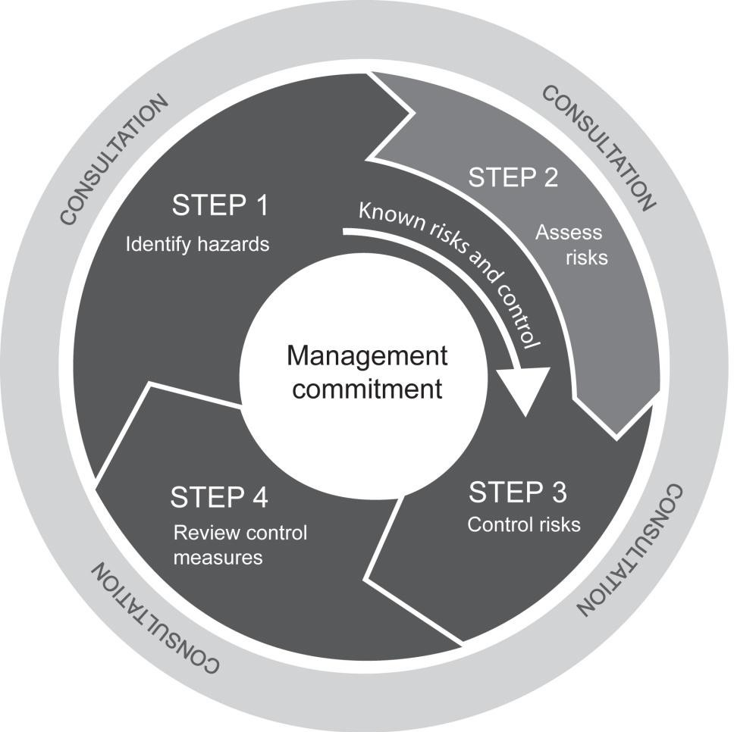

**Step 1 – Assessment of Risk**

1. The likelihood of an incident occurring as a result of the hazard will first be assessed.
2. The consequences (if an incident did occur) will then be determined. To determine the possible consequences, a judgement on the severity of the potential outcome will be made.

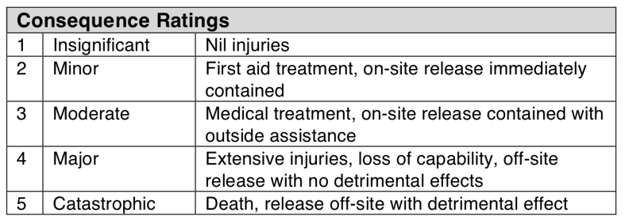

1. The likelihood and consequences estimates will then be combined to obtain a total risk score by using the following risk priority table.

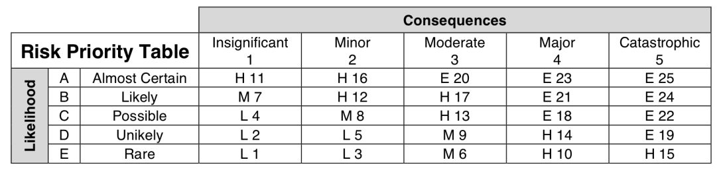

1. The following legend will be used to determine the response.

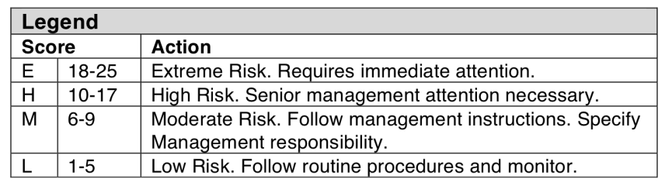

1. 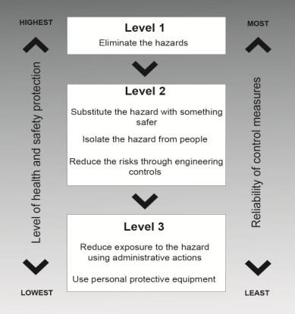Control measures will be implemented using the following hierarchy of controls.

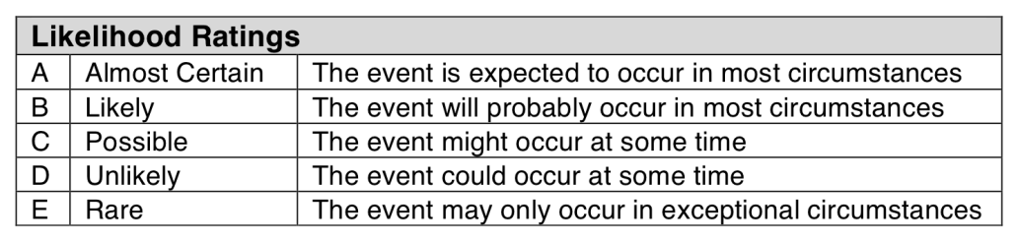

## Applicable Legislation, Standards, Competencies

|  |  |  |  |  |  |  |
| --- | --- | --- | --- | --- | --- | --- |
| **Relevant Legislation, Applicable Codes of Practices and Standards** | | | | | | |
| This Safe Work Method Statement has been developed to comply with the relevant legislation:  Work Health and Safety Act 2011 Work Health and Safety Regulation Environmental Protection Act 1994  Environmental Protection Regulation 2008  Environmental Protection (Waste) Policy and Regulation 2000 Environmental Protection (Water) Policy 2009  Environmental Protection (Noise) Policy 2008 Environmental Protection (Air) Policy 2008 | Relevant Codes of Practice, Standards and Guidelines as subordinate statute legislation including:  Hazardous Manual Tasks Code of Practice 2011  How to Manage Work Health and Safety Risks Code of Practice 2011 Managing the Work Environment and Facilities Code of Practice 2011 Work, Health and Safety Consultation Code of Practice 2011  Co-operation and Co-ordination Code of Practice 2011 Construction Work Code of Practice 2012  Excavation Work Code of Practice 2012  Managing Risks of Hazardous Chemicals in the Workplace Code of Practice 2012 Managing Noise and Hearing Loss at Work Code of Practice 2011  Plant Code of Practice 2005 | | | | | |
| **Training / Competencies / Certificates to perform work** | | | | | | |
| The following training / competencies are required to perform this task:  General Safety Induction Training (Construction Industry) Site Specific Induction (if required)  Work Activity Induction Training Equipment owner manuals  Safe Work Method Statements and Safe Work Procedures Training | Authorities to Work / Certificates of Competency for prescribed occupations / high risk work: (High Risk Work Certificates/ licences) | | | | | |
| ◻ | LE Excavator | ◻ | LS Skid Steer | ◻ | LB Front End Loader |
| ◻ | LS Skid Steer | ◻ | LZ Dozer | ◻ | DG Dogger |
| ◻ | LG Grader | ◻ | LP Scraper | ◻ | LR Roller |
| **Monitoring / Evaluation** | **Consultation & Communication** | | | | | |
| Measurement and evaluation will be an ongoing process performed principally by:   * Continuous monitoring by supervisor; * On site monitoring by Directors, General Manager, Operations Manager and Supervisor; * Formal site safety inspections against pre-determined criteria as per D&M Plant Hire Pty Ltd QHSEMS; * Formal incident investigation; and * Consultation with employees and contractors. | D&M Plant Hire Pty Ltd actively consult with workers and contractors through the following forms:   * Site visits / inspections by supervisors and partners; * Toolbox talks used to induct employees and contractors; * Regular staff meetings; * Correspondence to contractor via SMS, letter or email; * Company Newsletter; and * Other forums as determined. | | | | | |

**Consultation, Training and Competency Register**

|  |  |  |  |  |  |
| --- | --- | --- | --- | --- | --- |
| **Declaration by Employees and Contractors**  We, the undersigned, acknowledge that:   * This Safe Work Method Statement has been developed in consultation with us; and * We have been trained in the contents of this Safe Work Method Statement and are fully conversant with the safety procedures and precautions; and * We will work in accordance with the procedures listed in the Safe Work Method Statement. | | | | | |
| **Name** | **Signature** | **Date** | **Name** | **Signature** | **Date** |
|  |  |  |  |  |  |
|  |  |  |  |  |  |
|  |  |  |  |  |  |
|  |  |  |  |  |  |
|  |  |  |  |  |  |
|  |  |  |  |  |  |
|  |  |  |  |  |  |
|  |  |  |  |  |  |

|  |  |  |  |  |  |  |  |  |
| --- | --- | --- | --- | --- | --- | --- | --- | --- |
| **Doc / Record**  **No** | **Version** | **Date** | **Author** | **Approval** | **Sections Modified** | **Details of Amendments** | **Effective Date** | **Next Review** |
|  | 01 | 1/7/13 | Doug Phillips | Director | All | New document | 1/3/13 | 1/7/14 |
|  | 02 | 1/7/14 | Doug Phillips | Director | All | Reviewed | 1/7/14 | 1/7/15 |
|  | 03 | 1/7/15 | Doug Phillips | Director | All | Reviewed | 1/7/15 | 1/7/16 |
|  | 04 | 1/7/16 | Doug Phillips | Director | All | Reviewed | 1/7/16 | 1/7/17 |
|  | 05 | 1/7/17 | Ray Phillips | Director | All | New document | 1/7/17 | 1/7/18 |
| R30 | 01 | 1/7/18 | Ray Phillips | Director | All | Reviewed | 1/7/18 | 1/7/19 |
| R30.004 | 1.1 | 1/3/19 | Ray Phillips | Director | All | New document | 1/3/19 | 1/3/20 |
|  | 1.2 | 22/07/19 | Debra Wright | Manager | Selected | Updated |  |  |