|  |  |  |
| --- | --- | --- |
| **THIS SWMS HAS BEEN PREPARED AND AUTHORISED BY D&M PLANT HIRE PTY LTD** | | |
| **ABN: 57 010 542 506**  **P:** (07) 3286 5088 | **A:** 55 Enterprise St Cleveland Q 4163  **F:** (07) 3286 5088 | **P:** PO Box 1896, Cleveland QLD 4157  **E:** info@dandmplanthire.com.au |
| **Author:** Debra Wright | **Date:** 1st March 2019 | **Last Review Date:** 1/3/19 |
| **Approved By:** Ray Phillips | **Signature:** | **Next Review Date:** 1/3/20 |

|  |  |  |  |  |  |  |
| --- | --- | --- | --- | --- | --- | --- |
| **SWMS010 – OPERATION OF BACKHOE** | | | | | | |
| **Description of Work / Activity Undertaken:** | Operation of Backhoe | | | | | |
| **Person responsible for implementation / monitoring:** | Operator | | | | | |
| **Includes the following “High Risk Activities”:** |  | Work involving excavation to a depth  greater than 1.5 metres |  | Work on or near pressurised gas  distribution mains & consumer piping |  | Work on or near chemical, fuel or  refrigerant lines |
|  | Work adjacent to a road or railways used by road or rail traffic |  | Work on or near energised electrical installations & services |  | Work on sites with movement of powered mobile plant |

**This Safe Work Method Statement has been submitted to and approved by the following Principal Contractor / Customer**

|  |  |  |  |  |  |
| --- | --- | --- | --- | --- | --- |
| **Company Name:** |  | | | | |
| **Company Representative:** |  | | | | |
| **Site Address:** |  | | | | |
| **Period of Time** (max 12 months)**:** |  | | | | |
| **Approved By:** |  | **Signed:** |  | **Date:** |  |

**The following PPE items required to be used when performing this task: The following Plant/Equipment is required to be used when performing this task:**

|  |  |  |  |  |  |  |  |  |  |  |
| --- | --- | --- | --- | --- | --- | --- | --- | --- | --- | --- |
|  |  |  |  |  |  |  | **Other (list additional PPE items below):** |  |  | **Other (list additional plant/equipment items below):** |
| **☑**  **Safety**  **Boots** | **☑**  **Safety**  **Helmet** | **☑**  **Hearing**  **Protection** | **☑**  **Eye**  **Protection** | **☑**  **Hand**  **Protection** | **☑**  **High Vis**  **Clothing** | **◻**  **Respiratory**  **Protection** | **Backhoe** | **Float / Truck** |

| **STEP** | **TASK / ACTIVITY** | **HAZARD/S** | **RISK SCORE**  **(BEFORE CONTROLS)** | | | **CONTROL AND SAFE WORK PROCEDURES** | **RISK SCORE**  **(AFTER CONTROLS)** | | | **RESPONSIBLE PERSON** |
| --- | --- | --- | --- | --- | --- | --- | --- | --- | --- | --- |
| **L** | **C** | **R** | **L** | **C** | **R** |  |
| 1. | Arrival on site | Site management unaware of works  Incorrect machine / operator scheduled  Noncompliance of machine | C | 3 | H13 | 1. At time of booking/scheduling, sufficient information gathered as to determine particular needs of the site, any lift/s to be made and attachments required. 2. Type of machine selected to suit these particular needs addressing issues such as site terrain and conditions, existing services, rated capacity, site access and characteristics. 3. Evidence of Design Registration available and evidence of current Plant Registration with OHS authority clearly marked. 4. Operator’s Manual and applicable load charts maintained in cabin at all times. 5. Operator to have relevant licences/ cards on site at all times. 6. Manufacturer’s data plates in clear view. | E | 3 | M6 | Project Manager Operations Manager Operator |
| 2. | Delivery / float | Collision Crush Injuries  Property Damage | C | 3 | H13 | 1. Load/unload the backhoe on level, stable ground. 2. Check weather forecast and conditions for work area before loading/unloading, always exercise caution during inclement weather. 3. Make sure recommended distances from power lines are maintained when loading and unloading plant. 4. Make sure backhoe is centred on the vehicle and secured with the appropriate number of chains or ratchet straps as determined by relevant authority before transporting anywhere. 5. Use ramps to load and unload the backhoe. 6. Make sure the metal pins attached to the ramps are engaged and locked in place. 7. Make sure all personnel are clear of the loading ramp ‘swing arc’ area when the ramps are being lowered or raised, or when the ramps are raised and not secured. 8. When using wheel chocks, use only chocks which are contoured to the tyre diameter. | E | 3 | M6 | Project Manager Operator |
| 2 | Delivery / float | Collision Crush Injuries  Property Damage | C | 3 | H13 | 1. When winching, DO NOT place square or rectangular blocks made from timber, composite or steel etc. in front of or behind the wheels of the equipment being winched - The force applied to the corners of each block can cause the blocks to explosively eject and become potentially lethal projectiles. 2. Never use ramps to enter or exit the vehicle or trailer when on foot; 3. Provide adequate cover or protection to surfaces likely to be damaged by backhoe traffic. 4. Set out witches hats to provide a safe distance for the public to travel around the vehicle. 5. Use the ladders or steps to enter and exit vehicle or trailer when on foot. | E | 3 | M6 | Project Manager Operator |
| 3. | Access around site | Slips, trips and falls | C | 3 | H13 | 1. General access ways to be clear of hazards. 2. Materials / equipment not to be stored in access way. | E | 3 | M6 | Operator |
| 4. | Pre-site discussion and planning with Principal Contractor | Unforeseen hazards Unaware of site policies | C | 3 | H13 | 1. A pre-work discussion will be held and site-specific induction attended with the principal contractor to determine:  * Location of existing services including electricity and underground services; * Areas allocated for storage of materials and equipment; * Intended location for spoil and waste; * Anticipated scheduling and impact of other trades on site at the time of the works; * Other issues to plan and allow for the safe performance of works. | E | 3 | M6 | Project Manager Operator |
| 5. | Pre-work inspection / assessment | Existing services Plant Failure | C | 3 | H13 | 1. Prior to commencing work, a pre-work inspection is to be performed, recorded and signed on docket. 2. Items assessed to include location of electrical hazards, site terrain, availability and condition of PPE and first aid equipment and adequacy of this SWMS. 3. Pre-operational inspection performed to ensure machine/s if free from defects or faults. Inspection to include the following:  * Correct tyre pressure / tracks; * Park / foot brakes; * Steering; * Lift / bucket controls; * Warning devices – horn, flashing lights, reversing beeper, brake lights; * Hydraulics and other fluid levels; * Roll-over protective structures; * Locking pins; * Seat belts, other safeguards as per manufacturer’s recommendations. | E | 3 | M6 | Operator |
| 6. | Access in / out of plant | Unforeseen hazards Unaware of site policies | C | 3 | H13 | 1. Provision of adequate non-slip ladders, footholds, steps and grab rails so as to safely access cabins. 2. Correct use of these safeguards by operators. 3. Maintain three points of contact at all times. | E | 3 | M6 | Operator |
| 7. | Excavate / load material cont. | Falling objects and materials Overturn | C | 4 | E18 | 1. Machines to be only operated by certified persons. 2. Do not carry others on machine and machine only driven from operator’s seat. 3. Travel parallel with any slopes. Do not drive diagonally up or down a slope. 4. Machines operated and maintained in accordance to manufacturer’s instructions. 5. Unauthorised persons kept away from the mobile plant. Do not pass bucket or loads over others. 6. Underground services to be identified and marked out with principal contractor prior to works commencing. 7. Area clearly marked and barricaded where necessary to make safe from other traffic. 8. A safe travel speed maintained at all times. 9. Machine/s not to be left unattended. Lower bucket to ground, disengage controls, apply the park brake, switch off engine and remove key when not in use. | E | 3 | M6 | Operator |
| 8. | Placement of loaded materials | Trench / excavation collapse Falling objects | C | 4 | E18 | 1. Excavated materials loaded into truck to ensure:  * Materials not to be passed over anyone / cabin of vehicle.  1. Gross vehicle limits not to be exceeded.   AND   1. Placement of excavated materials on site to ensure:  * General access ways remain clear; * Not to present a hazard to other contractors / where arranged with principal contractor; * Sufficient distance from existing excavations so as not to present risk of collapse. | E | 3 | M6 | Operator |
| 9. | Working near existing services | Electrocution Explosion | D | 5 | E19 | 1. Existing services will be identified with the principal contractor prior to commencement. 2. An exclusion zone of 3 metres around overhead powerlines (up to 132kv) maintained which allows for sway and sag unless:    * Documentation from the power supply authority confirms the lines have been de- energised; or    * A suitably qualified safety observer is available when the crane could enter the exclusion zone and power supply authority has been as well as a documented safe system of work developed. | E | 5 | H15 | Operator |
| 10. | Inspection, Repairs and Maintenance | Plant Failure | D | 4 | H14 | 1. Planned inspections and preventative maintenance programs for plant in accordance with manufacturer’s recommendations and relevant Australian Standards (AS2250). 2. As a minimum this inspection program to include: 3. Daily / pre-operational inspections; 4. Routine weekly, monthly, quarterly and annual maintenance and independent inspections. 5. Inspections and maintenance to take place on level ground, with bucket lowered and machine turned off. 6. Do not attempt to maintain moving parts; two or more persons should work jointly. Avoid entanglement of jewellery and clothing in moving parts. 7. Records kept of all repair / replacement action required and taken in the form of a log book. 8. Instruction manuals giving sufficient information for operation, repairs and maintenance to be available at site of operation. 9. Up to date log books and inspection reports also available for inspection at site of operation. | E | 4 | H10 | Operator |
| 11. | Lifting of objects / materials by machine | Falling objects Overturn | C | 4 | E 18 | 1. Lifting area to be barricaded or use of spotter/s to maintain an exclusion zone. 2. Where lane closure or similar controls required signage and barricading in accordance with AS 1742 Manual of Uniform Traffic Control Devices. 3. Pre-operational inspections and checks of safety devices in accordance with the operator’s manual performed by operator before use. 4. Lifts only performed by competent and certified operators in accordance with operations manual and manufacturer’s recommendations. 5. Load charts and functions and limitations to be clearly visible and followed. 6. Operator to have a clear view of load at all times otherwise dogger/s to be used. 7. The instructions of the operator and dogger to be followed at all times. 8. Only necessary and minimal personnel to be in lifting zone during lifting of loads. 9. Weather conditions to be considered prior to lifts. 10. Loads not to be lifted over members of the public or other trades. 11. Operator to remain in cabin at all times whilst load is suspended. | E | 3 | M6 | Operator |
| 12. | Operation with attachments including rock breaker, post hole borer, rock grab, ripper, vibration plate and compaction wheel | Falling objects Noise Entanglement Dust | C | 4 | E 18 | 1. Refer operational controls previously. 2. Use attachments only for their intended purpose and as recommended by manufacturer. 3. Operate attachments in front or in back of the machine only. 4. Additional care to be taken when transporting the machine to ensure the chisel or other attachments does not interfere with the boom. 5. Work to cease if the hydraulic hoses vibrate abnormally. 6. Exclusion zone to be maintained from attachments to avoid entanglement and flying fragments. 7. Hearing protection to be worn by all personnel. 8. Dust suppression methods used, or respiratory protection worn. | E | 3 | M8 | Operator |
| 13. | Loading and unloading of machine | Collision Crush Injuries | C | 4 | E 18 | 1. Clear and safe access way provided for float / trucks to loading area. 2. Principal Contractor Traffic Safety Management Plan to be adhered to. 3. Spotter used to assist truck drivers to reverse. Spotter to always remain in driver’s vision. 4. Persons are not to position themselves between a reversing truck and equipment / materials / structures. 5. Safety instructions of driver to be followed at all times. 6. Inspection of ramps / equipment prior to loading. 7. Safe loading speed to be maintained. | E | 3 | M6 | Operator |
| 14. | Work adjacent to a road or railway | Collision Impact  Vehicle and mobile plant traffic | C | 5 | E 22 | **D&M Plant Hire Pty Ltd working under principal contractor traffic management plan**   1. All workers to be trained / inducted into Traffic Control Plan. 2. Safety instructions and directions of Traffic Control personnel to be followed. 3. Site rules and Site Traffic Management Plan to be adhered to at all times. 4. Traffic management devices including barriers, signage and bollards not to be interfered with, relocated or subjected to damage. 5. Defective / ineffective traffic control devices brought to the attention of the principal contractor 6. Workers familiar with the basic application of the Manual for Uniform Traffic Devices Part 3 and adherence to this Part   **Traffic Management Plan devised by D&M Plant Hire Pty Ltd**   1. A traffic management plan to be developed by D&M Plant Hire Pty Ltd and all workers trained and familiar with the plan. 2. Traffic Management Plan to be approved by Principal Contractor prior to work commencing. 3. Road work signage and devices to be erected prior to work commencing and in accordance with AS 1742.3 4. Daily inspections to be carried out and documented prior to work commencing each morning. 5. Traffic control only by approved and accredited personnel. | E | 4 | H 10 | Principal Contractor Operator |
| 16.  cont. | Work adjacent to a road or railway cont. | Collision Impact  Vehicle and mobile plant traffic cont. | C | 5 | E 22 | 1. Work zones to be delineated in accordance with Traffic Management Plan All workers to remain within the work zone, unless otherwise directed by Traffic Controllers 2. Continuous monitoring by supervisor of signage, devices and effectiveness of the Traffic Management Plan and appropriate remedial action taken as necessary. 3. Prestart meetings to be held to ensure all workers are aware of control measures. | E | 4 | H10 | Principal Contractor Operator  All personnel |
| 17. | Working in or near  waterways | Impact on waterway from  works leading to an impact on. | C | 3 | H13 | 1. If crossing is required, then approval shall be   sought from the local waterway before any work can take place.   1. Ensure that erosion and sediment controls are in place prior to disturbance of the waterway. 2. Operator to ensure that other operators on site are aware and ready to respond to potential drowning accidents. | D | 2 | L5 | Principal Contractor  and Operator |
| 18 | Working in and around bodies of water | Drowning | C | 5 | E22 | 1. When working near bodies of water, ensure that machinery stays clear of the water’s edge. 2. JSA of the ground (including firmness of ground) in the area of operation to be performed prior to any work being performed. 3. Operator to ensure that other operators on site are aware and ready to respond to potential drowning accidents. | E | 3 | H10 | Principal Contractor  All personnel |
| 19. | Leave Site | Damage to property or plant Struck by moving objects | C | 4 | E18 | 1. Areas left in a clean and tidy state. 2. Sign out procedures of principal contractor followed. 3. Environmental wash station / gravel driveways utilised. 4. Lock and secure site if required. 5. Traffic management procedures of principal contractor followed. | E | 3 | M6 | Project Manager Operator |
| 20. | Working in a dusty work zone | Irritation, asthma and/or damage to operators lungs. | C | 2 | M8 | 1. Where high levels of dust are generated and not suppressed by site controls, report incident to site management. Site management to implement controls in so far as it is practicable. 2. Ensure cabin windows are closed as practicable and air-conditioning is set to recycled and not vented. 3. Wear a dust mask as practicable. | E | 2 | L3 | Operator | |
| 21. | Working in quarries or on sites where materials high in quartz are being cut or ground. | Inhalation of silica dust leading to lung disease.  **Note**: *Silica particles are naturally occurring in quartz and may be used in small percentages in the manufacture of cement and construction materials. The risk arises where silica particles become airborne during cutting, grinding or crushing.* | D | 3 | M9 | 1. Where high levels of silica dust are generated and not suppressed by site controls, report incident to site management. Site management to implement controls in so far as it is practicable. 2. Ensure cabin windows are closed as practicable and air-conditioning is set to recycled and not vented. 3. Wear a respirator mask with P2 cartridges, as practicable. | D | 1 | L2 | Operator | |

**Additional Hazards / Tasks / Special Precautions / Control Measure** *(to be completed where review / site specific conditions may determine necessary)*

Use the Risk Management Process on Page 12 of this document to determine appropriate control measures

|  |  |  |  |  |  |  |  |  |  |  |
| --- | --- | --- | --- | --- | --- | --- | --- | --- | --- | --- |
| **STEP** | **TASK / ACTIVITY** | **HAZARD/S** | **RISK SCORE**  **(BEFORE CONTROLS)** | | | **CONTROL AND SAFE WORK PROCEDURES** | **RISK SCORE**  **(AFTER CONTROLS)** | | | **RESPONSIBLE PERSON** |
| **L** | **C** | **R** | **L** | **C** | **R** |
|  |  |  |  |  |  |  |  |  |  |  |
|  |  |  |  |  |  |  |  |  |  |  |
|  |  |  |  |  |  |  |  |  |  |  |
|  |  |  |  |  |  |  |  |  |  |  |

# Risk Management Process

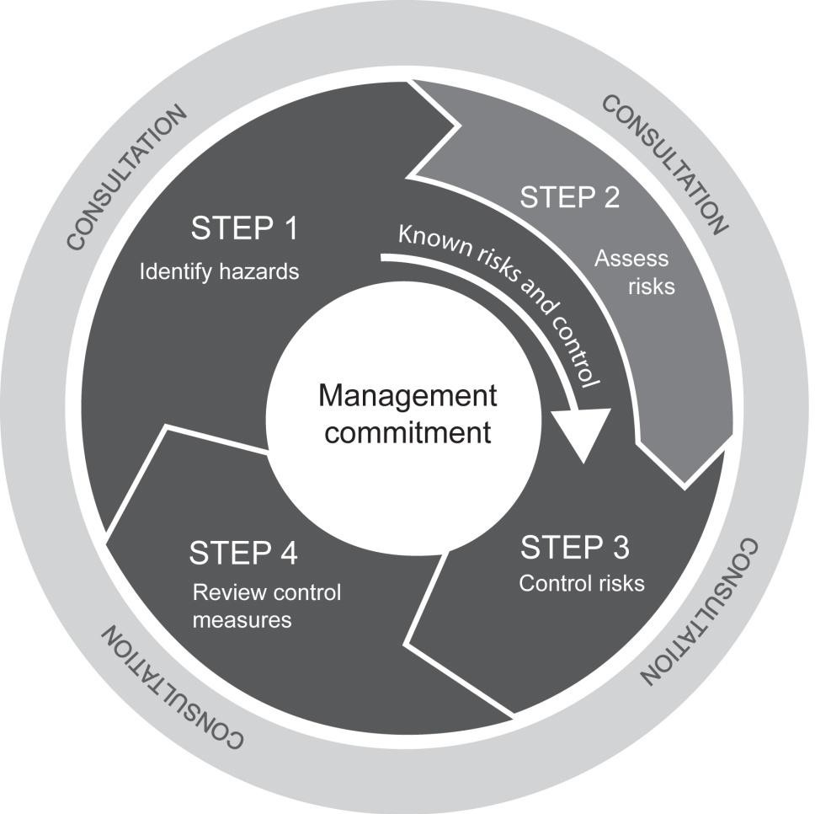

**Step 1 – Assessment of Risk**

1. The likelihood of an incident occurring as a result of the hazard will first be assessed.
2. The consequences (if an incident did occur) will then be determined. To determine the possible consequences, a judgement on the severity of the potential outcome will be made.

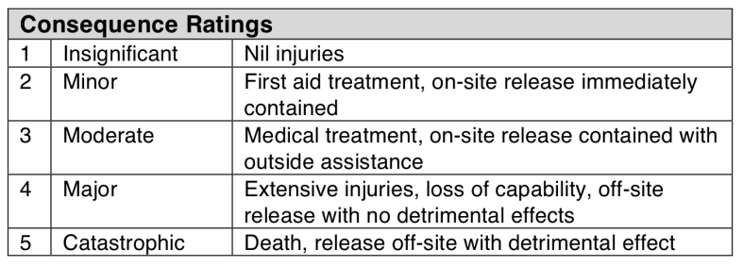

1. The likelihood and consequences estimates will then be combined to obtain a total risk score by using the following risk priority table.

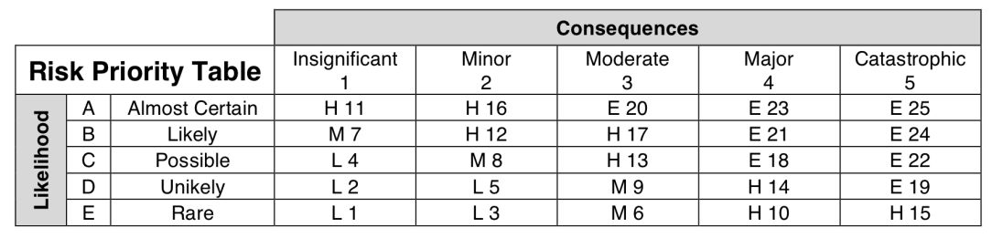

1. The following legend will be used to determine the response.

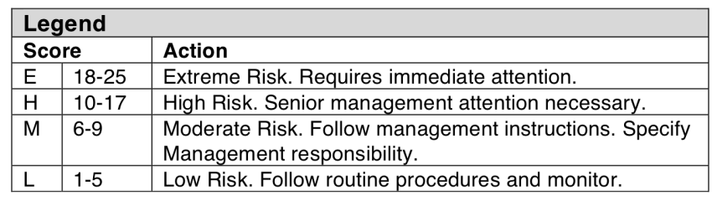

1. 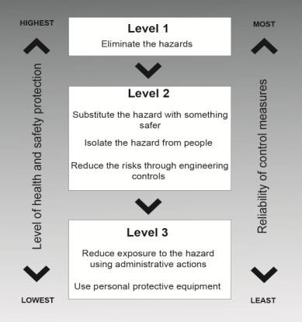Control measures will be implemented using the following hierarchy of controls.

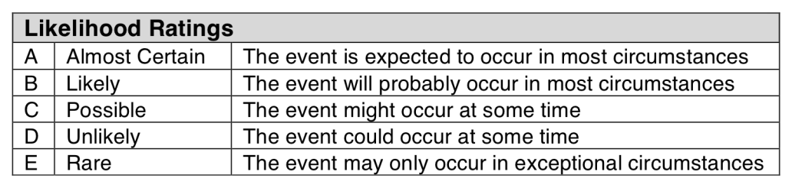

## Applicable Legislation, Standards, Competencies

|  |  |  |  |  |  |  |
| --- | --- | --- | --- | --- | --- | --- |
| **Relevant Legislation, Applicable Codes of Practices and Standards** | | | | | | |
| This Safe Work Method Statement has been developed to comply with the relevant legislation:  Work Health and Safety Act 2011 Work Health and Safety Regulation Environmental Protection Act 1994  Environmental Protection Regulation 2008  Environmental Protection (Waste) Policy and Regulation 2000 Environmental Protection (Water) Policy 2009  Environmental Protection (Noise) Policy 2008 Environmental Protection (Air) Policy 2008 | Relevant Codes of Practice, Standards and Guidelines as subordinate statute legislation including:  Hazardous Manual Tasks Code of Practice 2011  How to Manage Work Health and Safety Risks Code of Practice 2011 Managing the Work Environment and Facilities Code of Practice 2011 Work, Health and Safety Consultation Code of Practice 2011  Co-operation and Co-ordination Code of Practice 2011 Construction Work Code of Practice 2012  Excavation Work Code of Practice 2012  Managing Risks of Hazardous Chemicals in the Workplace Code of Practice 2012 Managing Noise and Hearing Loss at Work Code of Practice 2011  Plant Code of Practice 2005 | | | | | |
| **Training / Competencies / Certificates to perform work** | | | | | | |
| The following training / competencies are required to perform this task:  General Safety Induction Training (Construction Industry) Site Specific Induction (if required)  Work Activity Induction Training Equipment owner manuals  Safe Work Method Statements and Safe Work Procedures Training | Authorities to Work / Certificates of Competency for prescribed occupations / high risk work: | | | | | |
| ◻ | LE Excavator | ◻ | LS Skid Steer | ☑ | LB Backhoe Front End Loader |
| ◻ | LG Grader | ◻ | LZ Dozer |  |  |
| ◻ | LP Scraper | ◻ | LR Roller |  |  |
| **Monitoring / Evaluation** | **Consultation & Communication** | | | | | |
| Measurement and evaluation will be an ongoing process performed principally by:   * Continuous monitoring by supervisor; * On site monitoring by Directors, General Manager, Operations Manager and Supervisor; * Formal site safety inspections against pre-determined criteria as per D&M Plant Hire Pty Ltd QHSEMS; * Formal incident investigation; and * Consultation with employees and contractors. | D&M Plant Hire Pty Ltd actively consult with workers and contractors through the following forms:   * Site visits / inspections by supervisors and partners; * Toolbox talks used to induct employees and contractors; * Regular staff meetings; * Correspondence to contractor via SMS, letter or email; * Company Newsletter; and * Other forums as determined. | | | | | |

**Consultation, Training and Competency Register**

|  |  |  |  |  |  |
| --- | --- | --- | --- | --- | --- |
| **Declaration by Employees and Contractors**  We, the undersigned, acknowledge that:   * This Safe Work Method Statement has been developed in consultation with us; and * We have been trained in the contents of this Safe Work Method Statement and are fully conversant with the safety procedures and precautions; and * We will work in accordance with the procedures listed in the Safe Work Method Statement. | | | | | |
| **Name** | **Signature** | **Date** | **Name** | **Signature** | **Date** |
|  |  |  |  |  |  |
|  |  |  |  |  |  |
|  |  |  |  |  |  |
|  |  |  |  |  |  |
|  |  |  |  |  |  |
|  |  |  |  |  |  |
|  |  |  |  |  |  |
|  |  |  |  |  |  |

|  |  |  |  |  |  |  |  |  |
| --- | --- | --- | --- | --- | --- | --- | --- | --- |
| **Doc / Record**  **No** | **Version** | **Date** | **Author** | **Approval** | **Sections Modified** | **Details of Amendments** | **Effective Date** | **Next Review** |
|  | 01 | 1/7/13 | Doug Phillips | Director | All | New document | 1/3/13 | 1/7/14 |
|  | 02 | 1/7/14 | Doug Phillips | Director | All | Reviewed | 1/7/14 | 1/7/15 |
|  | 03 | 1/7/15 | Doug Phillips | Director | All | Reviewed | 1/7/15 | 1/7/16 |
|  | 04 | 1/7/16 | Doug Phillips | Director | All | Reviewed | 1/7/16 | 1/7/17 |
|  | 05 | 1/7/17 | Ray Phillips | Director | All | New document | 1/7/17 | 1/7/18 |
| R30 | 01 | 1/7/18 | Ray Phillips | Director | All | Reviewed | 1/7/18 | 1/7/19 |
| R30.010 | 1.1 | 1/3/19 | Ray Phillips | Director | All | New document | 1/3/19 | 1/7/20 |
|  | 1.2 | 22/07/19 | Debra Wright | Manager | Selected | Updated |  |  |